

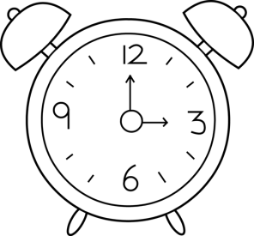Name _____________________________________________

What time is it?

|  |  |
| --- | --- |
| Friend | Time |

:

:

:

:

:

:

:

:

:

: