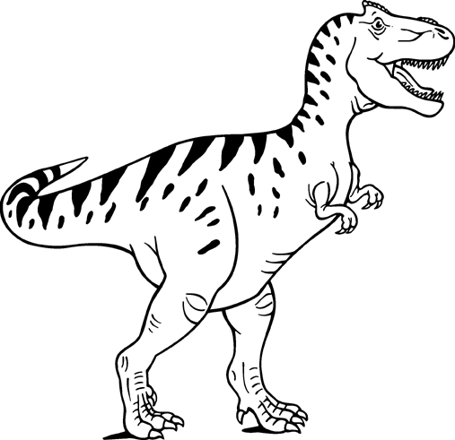
DINOSAUR MATH
Width
Length

Using Rulers
- How many rulers make the length of a T-Rex foot? ____________

- How many rules make the width of the T-Rex foot? ____________

Using Circle Pieces
- How many circle pieces does it take to make the length of a T-Rex foot? ____________

- How many circle pieces does it take to make the width of a T-Rex foot? ____________

Using Your Feet
- How many of your feet does it take to make the length of a T-Rex foot? ____________

- How many of your feet does it take to make the width of a T-Rex foot? ____________

Using Your Hands
- How many of your hands does it take to make the length of a T-Rex foot? ___________

- How many of your hands does it take to make the width of a T-Rex foot? ___________

Using Blocks
- How many blocks does it take to make the length of a T-Rex foot? ____________

- How many blocks does it take to make the width of a T-Rex foot? ____________

Using Pencils
- How many pencils does it take to make the length of a T-Rex foot? ____________

- How many pencils does it take to make the width of a T-Rex foot? ____________

